CRUD APPLICATION FOR LIBRARY RECORDS

EXPLANATION

* Our Group created a website using XAMPP in which you can create, read, update and delete users.
* It is a website for Students who are checking out books from a library to know who checked out what book and what time you checked out
* It has the following columns: Name, Matric. No, Department, Book selected, and time you Checked Out

|  |  |
| --- | --- |
| Daniel Toluwanimi Akintelu | BHU/23/04/05/0086 |
| Uforo Udoh | BHU/23/04/05/0094 |
| Kayode Miracles | BHU/23/04/09/0060 |
| Emmanuel Ohiliyoma Ngbede | BHU/23/04/09/0062 |
| Felix Igbarease | BHU/23/04/05/0089 |

ABOUT

**Daniel Toluwanimi Akintelu BHU/23/04/05/0086**

The First Thing We did was create a login page. In which the Librarian can login to her account and see what is going on in there library

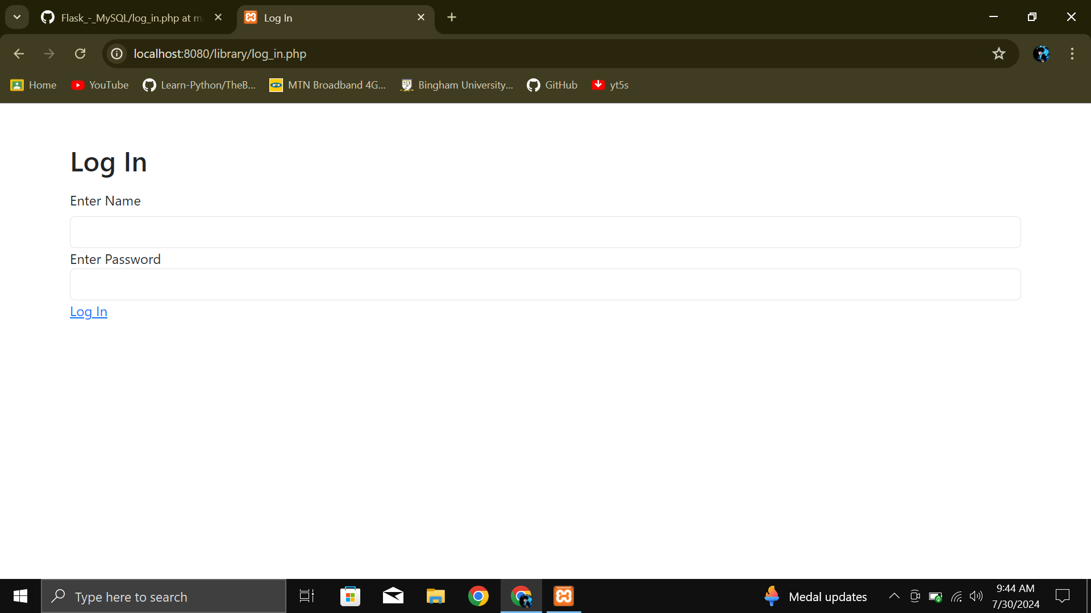

We then created the database structure and how the table should look-like in phpMyAdmin.

We made the ID a primary Key and Auto Incremented. Also the matric Unique so that two people cant have the same matric number.

We also made the check out timestamp to show the exact time that it was checked out.

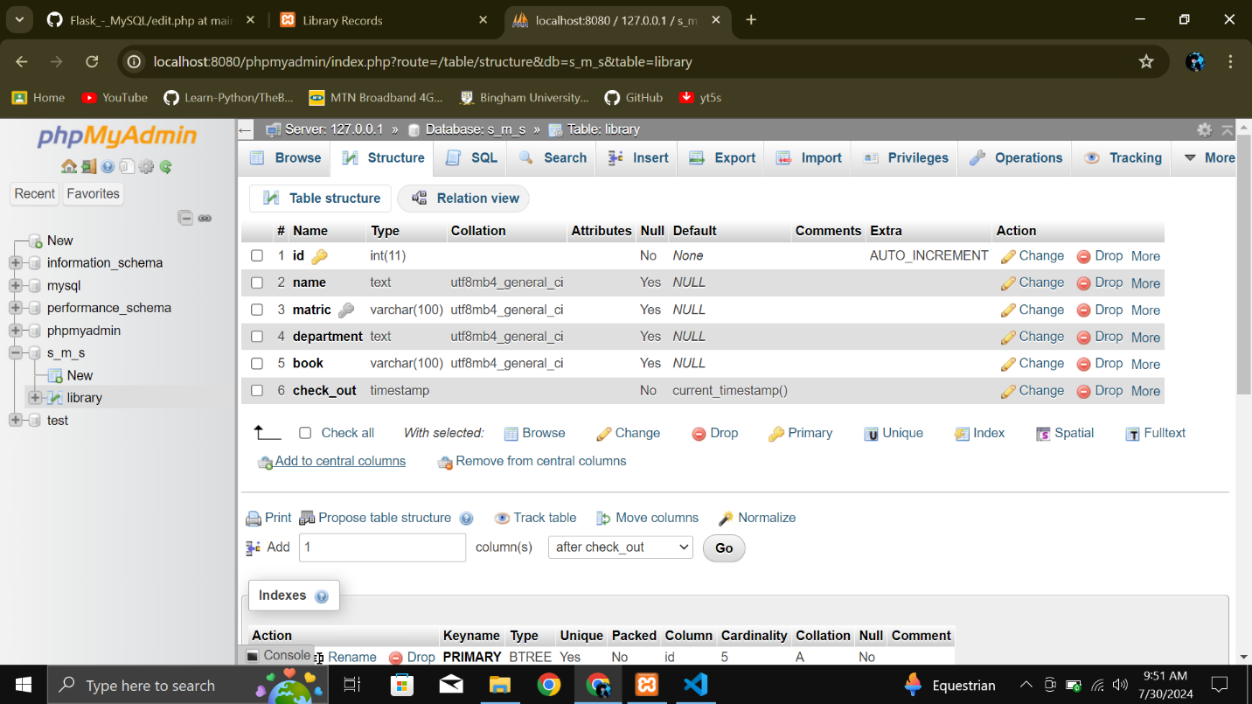

The next thing done, was to create examples to verify that table was created well

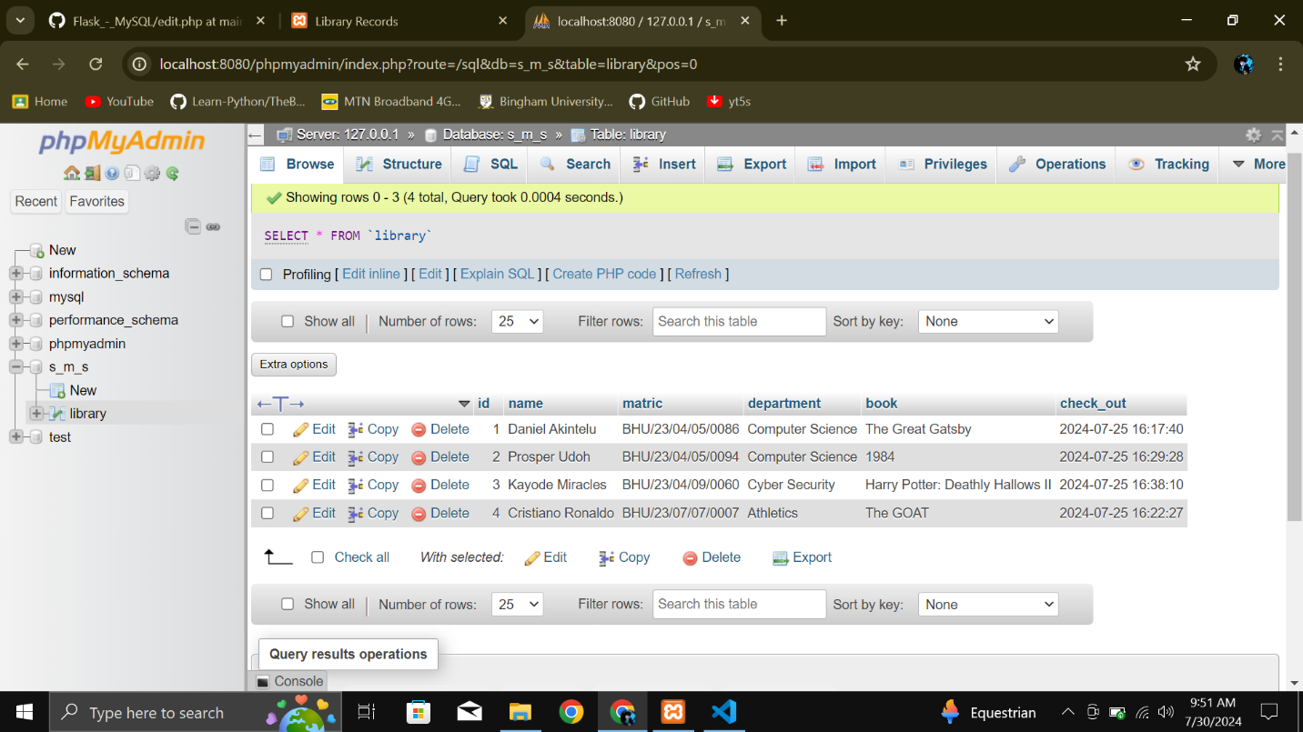

**Uforo Udoh BHU/23/04/05/0086**

The next thing we did was create an index page where the table will be published. It is the place the Librarian will be mostly

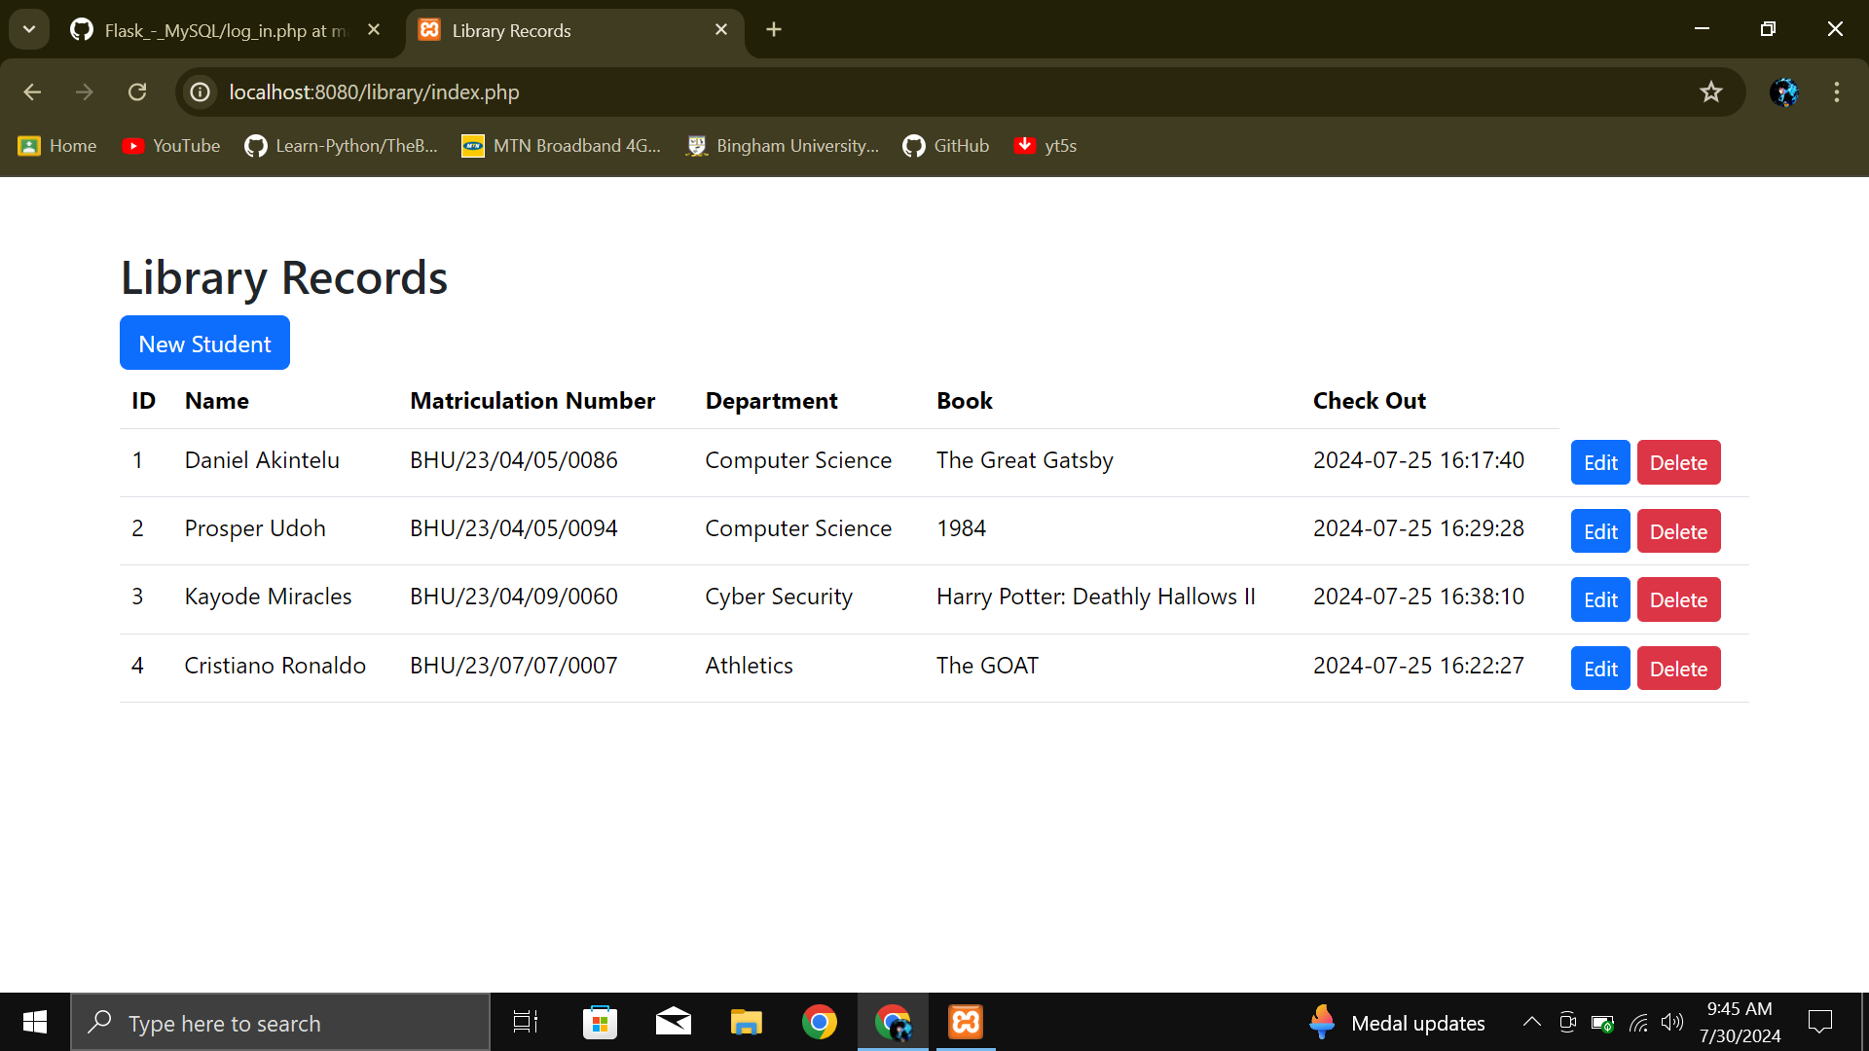

**Ngbede Emmanuel BHU/23/04/09/0062**

We then made a create page In which the Librarian will create a student who wants to check out a book.

With their Name, Matric Number, and Department Included.

By just clicking on the New students button on the index page

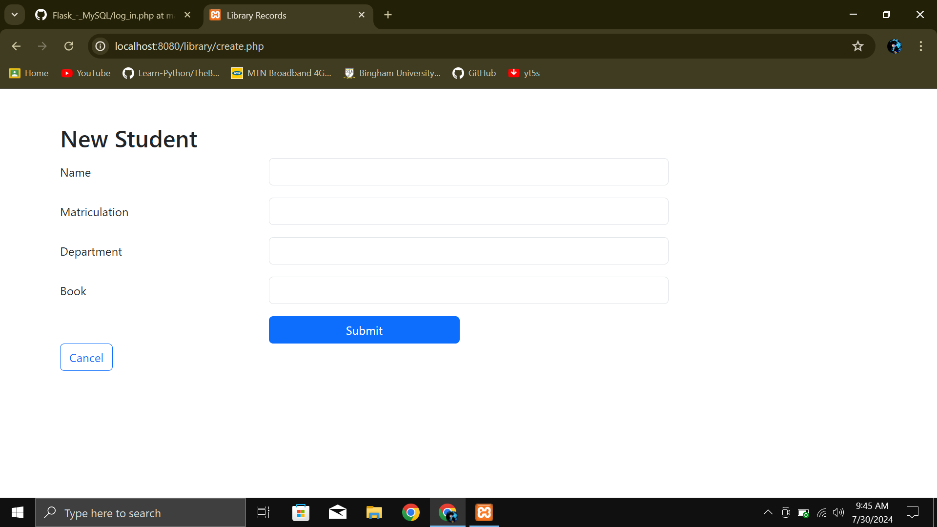

**Felix Igberaese BHU/23/04/05/0089**

We then created and edit page where the librarian can edit the students profile. By just pressing the edit button.

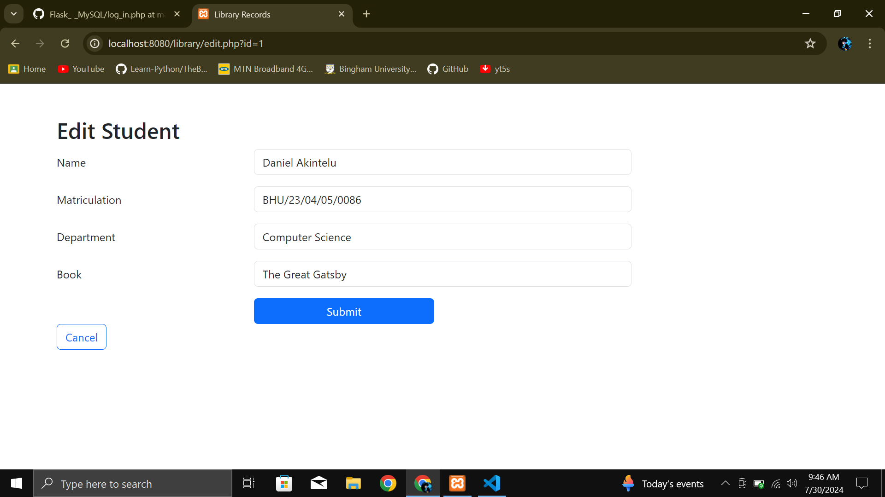

**Kayode Miracle BHU/23/04/09/0060**

Lastly we created a Delete button, by simply just clicking the delete button a profile will be deleted.